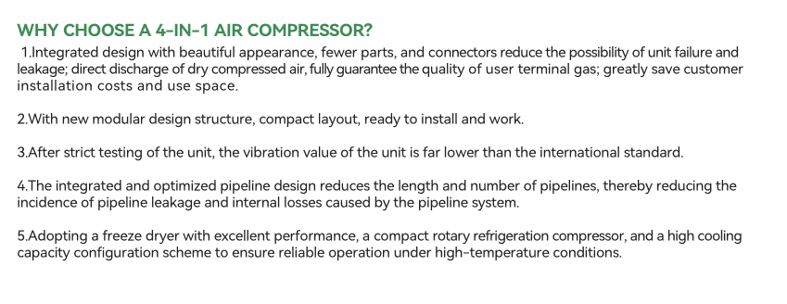
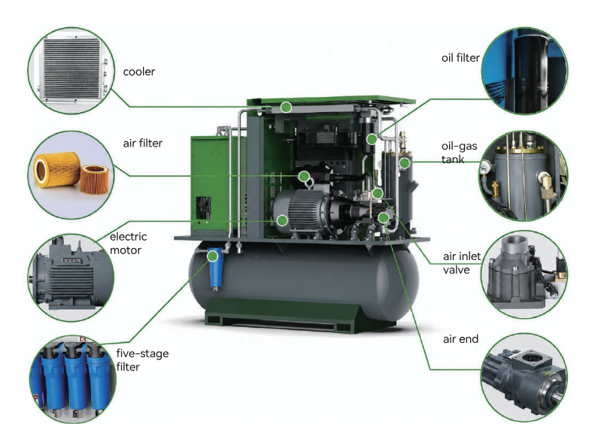
4 -IN-1 AIR COMPRESSOR

Fixed Speed Screw Air Compressor Specification 4 IN 1 PM VSD `Screw Air Compressor Specification 4 IN 1
Two-Stage PM VSD Screw Air Compressor

